M7.2 Assignment
Course: CSD310 – 340A
Prepared By: Mirach Erkol
Date of Report: 11/30/2025

https://github.com/Mikey5007/csd-310.git

M7.2 Assignment: Screenshot #1, CLI

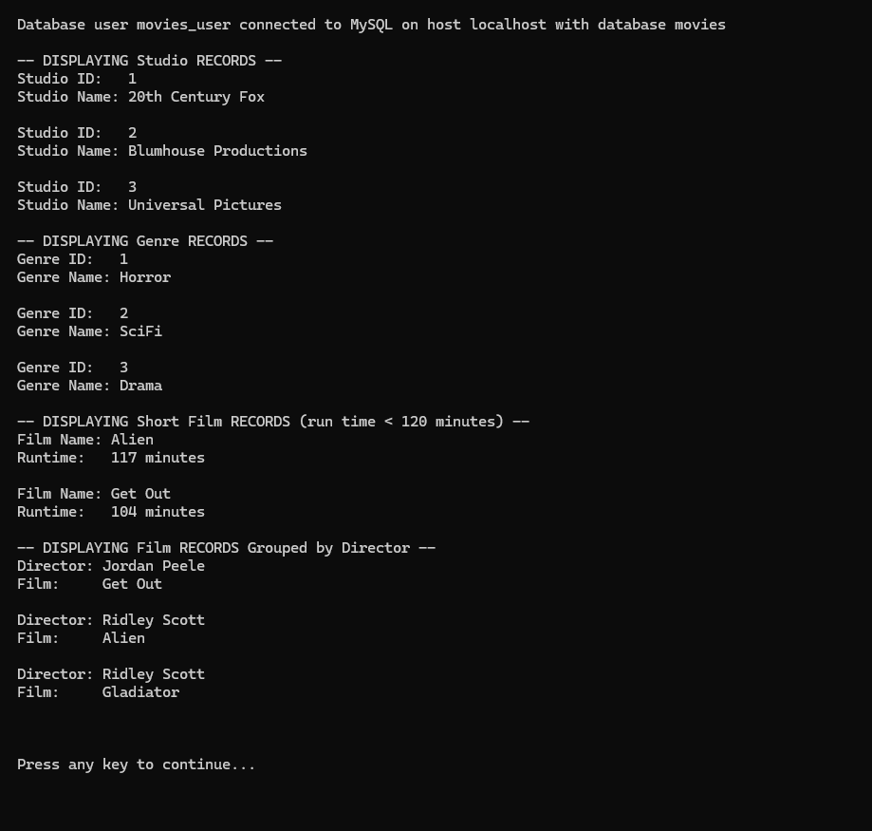

M7.2 Assignment: Screenshot #2, Pycharm

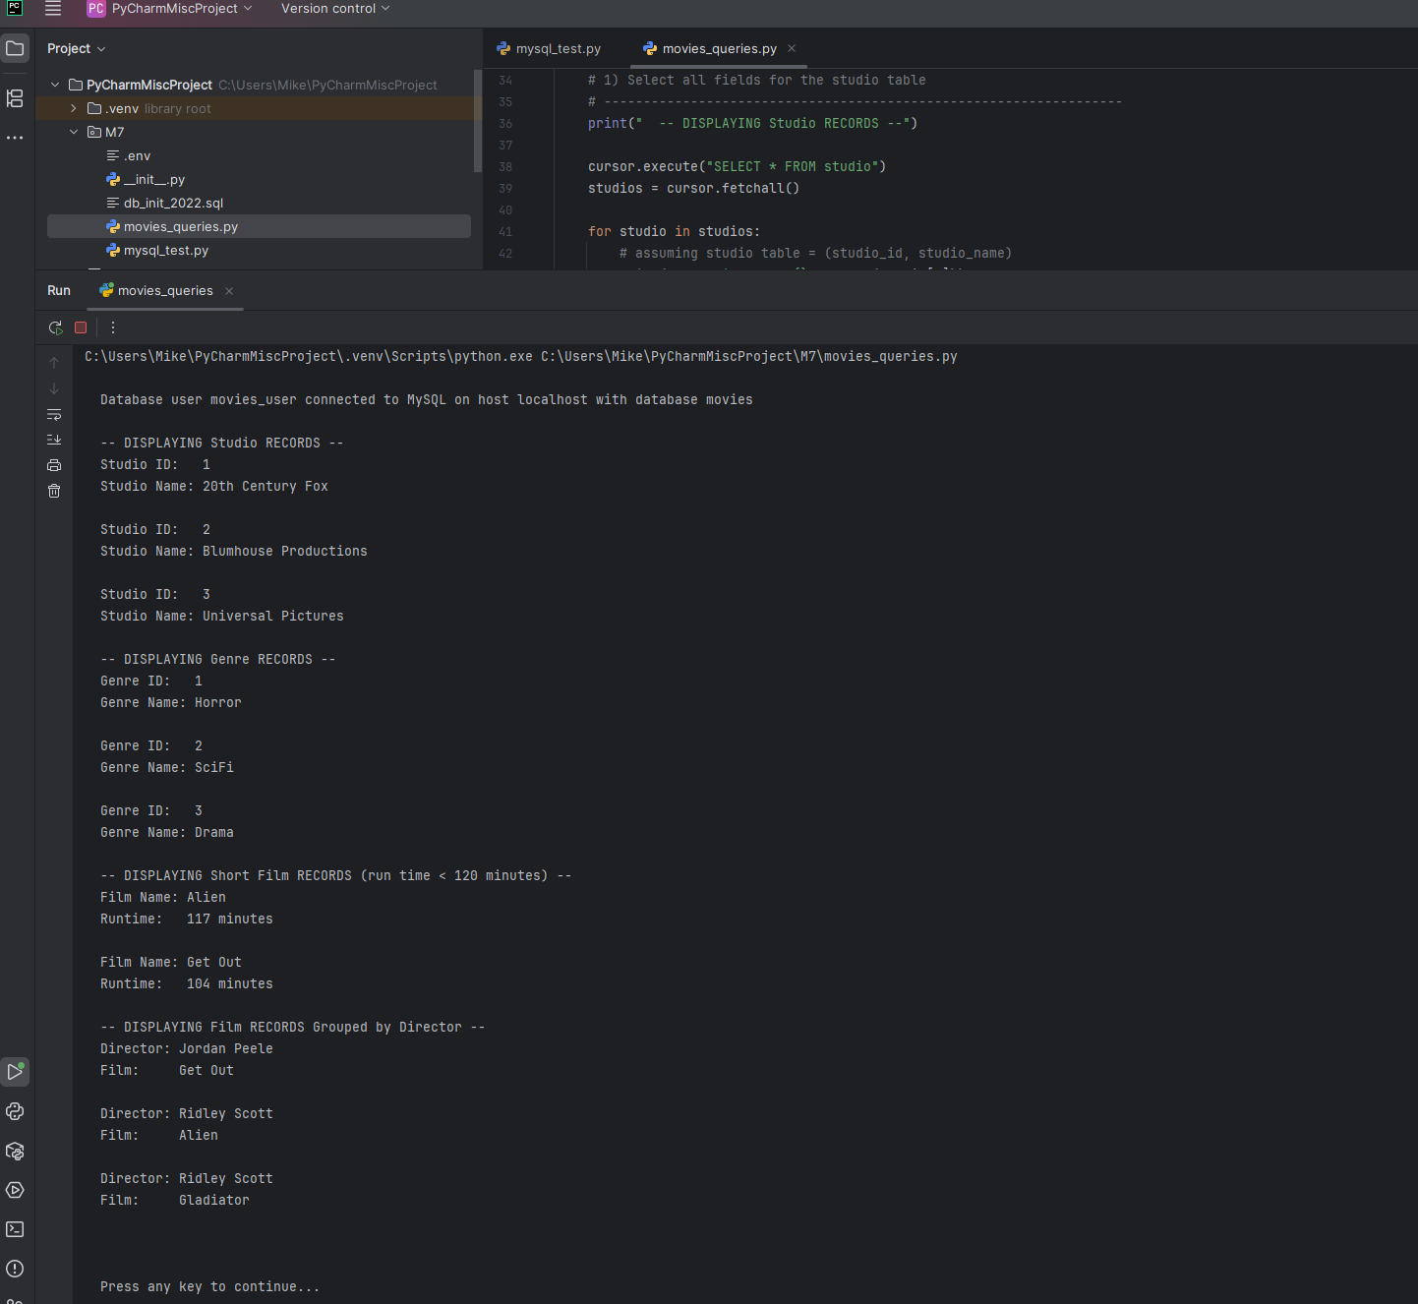

Mikey5007/csd-310: CSD

